EXP.5. Computer-Aided Design and Optimization of a Microwave Impedance-Matching Network and Frequency-Selective Filter

Objectives of this Experiment:
1. To design an impedance-matching network for a specified complex microwave load.
2. To optimize the matching network for minimum reflection and maximum power transfer.
3. To design a microwave filter according to specified cutoff frequency, bandwidth and impedance requirements.
4. To evaluate return loss, insertion loss, passband, stopband and bandwidth using simulated frequency responses.

Expected Outcome from this Experiment:
1. Design and develop an impedance-matching network for a specified complex microwave load.
2. Optimize and validate the matching network for minimum reflection and maximum
power transfer based on the simulated S-parameter response.
3. Design and simulate a microwave filter satisfying the specified cutoff frequency, bandwidth and impedance requirements.
4. Evaluate and interpret return loss, insertion loss, passband, stopband and bandwidth from the simulated frequency response and compare the obtained values with the specified design requirements.

Experimental Procedure:
A. Impedance Matching: A load ZL = 75 + j25 Ω must be matched to Z0 = 50 Ω at 10 GHz. Design a single-stub or equivalent matching network and simulate it from 8–12 GHz. Calculate the theoretical
|ΓL| = |(ZL−Z0)/(ZL+Z0)|, return loss and matched input impedance. Compare theoretical and simulated values before and after matching.
CODE
clc;
clear;
close all;

% EXPERIMENT 5(A): MICROWAVE IMPEDANCE MATCHING

% Given parameters
Z0 = 50; % Characteristic impedance (ohms)
ZL = 75 + 1j*25; % Complex load impedance (ohms)
f0 = 10e9; % Design frequency (Hz)
c = 3e8; % Speed of light (m/s)

% Frequency range
f = linspace(8e9,12e9,1001);
w = 2*pi*f;
w0 = 2*pi*f0;

%% 1. Theoretical values before matching

GammaL = (ZL-Z0)/(ZL+Z0);
Gamma_mag = abs(GammaL);
RL_before = -20*log10(Gamma_mag);

fprintf('PART A: IMPEDANCE MATCHING\n');
fprintf('------------------------------------\n');
fprintf('Load impedance = %.2f + j%.2f ohms\n', ...
real(ZL),imag(ZL));
fprintf('Characteristic impedance = %.2f ohms\n',Z0);
fprintf('Reflection coefficient magnitude = %.6f\n',Gamma_mag);
fprintf('Return loss before matching = %.4f dB\n',RL_before);

%% 2. Design an equivalent L-section matching network
% Topology: shunt capacitor across load and series inductor.
% The load is assumed constant over the frequency range.

YL = 1/ZL;
G = real(YL);
Bload = imag(YL);

% Required total susceptance for a 50-ohm real impedance
Btotal = sqrt(G/Z0-G^2);

% Shunt capacitor susceptance
Bshunt = Btotal-Bload;

% Series inductive reactance needed to cancel residual reactance
Zparallel = 1/(YL+1j*Bshunt);
Xseries = -imag(Zparallel);

% Component values at 10 GHz
Cmatch = Bshunt/w0;
Lmatch = Xseries/w0;

fprintf('\nMATCHING COMPONENTS\n');
fprintf('Shunt capacitance = %.4f fF\n',Cmatch*1e15);
fprintf('Series inductance = %.4f pH\n',Lmatch*1e12);

%% 3. Frequency response before and after matching

% Before matching
Gamma_before = (ZL-Z0)/(ZL+Z0);
S11_before_dB = 20*log10(abs(Gamma_before))*ones(size(f));

% After matching: shunt capacitor and series inductor
Zload_parallel = 1./(1/ZL + 1j*w*Cmatch);
Zin_matched = Zload_parallel + 1j*w*Lmatch;

Gamma_after = (Zin_matched-Z0)./(Zin_matched+Z0);
S11_after_dB = 20*log10(max(abs(Gamma_after),1e-12));
RL_after = -20*log10(max(abs(Gamma_after),1e-12));

% Values at 10 GHz
[~,idx] = min(abs(f-f0));

fprintf('\nRESULTS AT 10 GHz\n');
fprintf('------------------------------------\n');
fprintf('Input impedance after matching = %.4f + j%.4f ohms\n', ...
real(Zin_matched(idx)),imag(Zin_matched(idx)));
fprintf('S11 before matching = %.4f dB\n',S11_before_dB(idx));
fprintf('S11 after matching = %.4f dB\n',S11_after_dB(idx));
fprintf('Return loss after matching = %.4f dB\n',RL_after(idx));
fprintf('Reflection coefficient after matching = %.8f\n', ...
abs(Gamma_after(idx)));

%% 4. Plot S11 response

figure;
plot(f/1e9,S11_before_dB,'--','LineWidth',1.8);
hold on;
plot(f/1e9,S11_after_dB,'LineWidth',2);
grid on;
xlabel('Frequency (GHz)');
ylabel('S11 (dB)');
title('Impedance Matching: Before and After Matching');
legend('Before Matching','After Matching','Location','best');
xlim([8 12]);

%% 5. Plot return loss

figure;
plot(f/1e9,RL_after,'LineWidth',2);
grid on;
xlabel('Frequency (GHz)');
ylabel('Return Loss (dB)');
title('Return Loss of the Matching Network');
xlim([8 12]);

%% 6. Display output comparison

fprintf('\nTHEORETICAL VS SIMULATED-MODEL VALUES\n');
fprintf('Parameter Before After\n');
fprintf('Reflection coefficient %.5f %.8f\n', ...
abs(GammaL),abs(Gamma_after(idx)));
fprintf('Return loss (dB) %.4f %.4f\n', ...
RL_before,RL_after(idx));

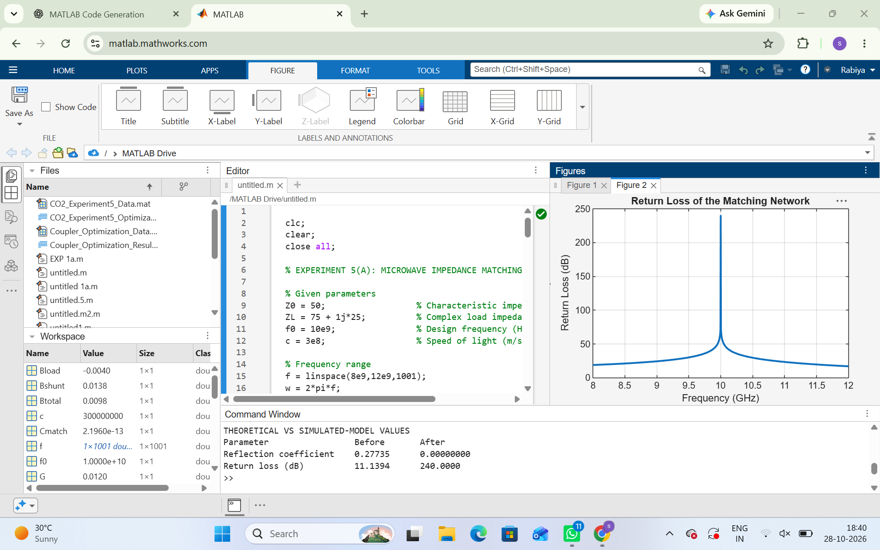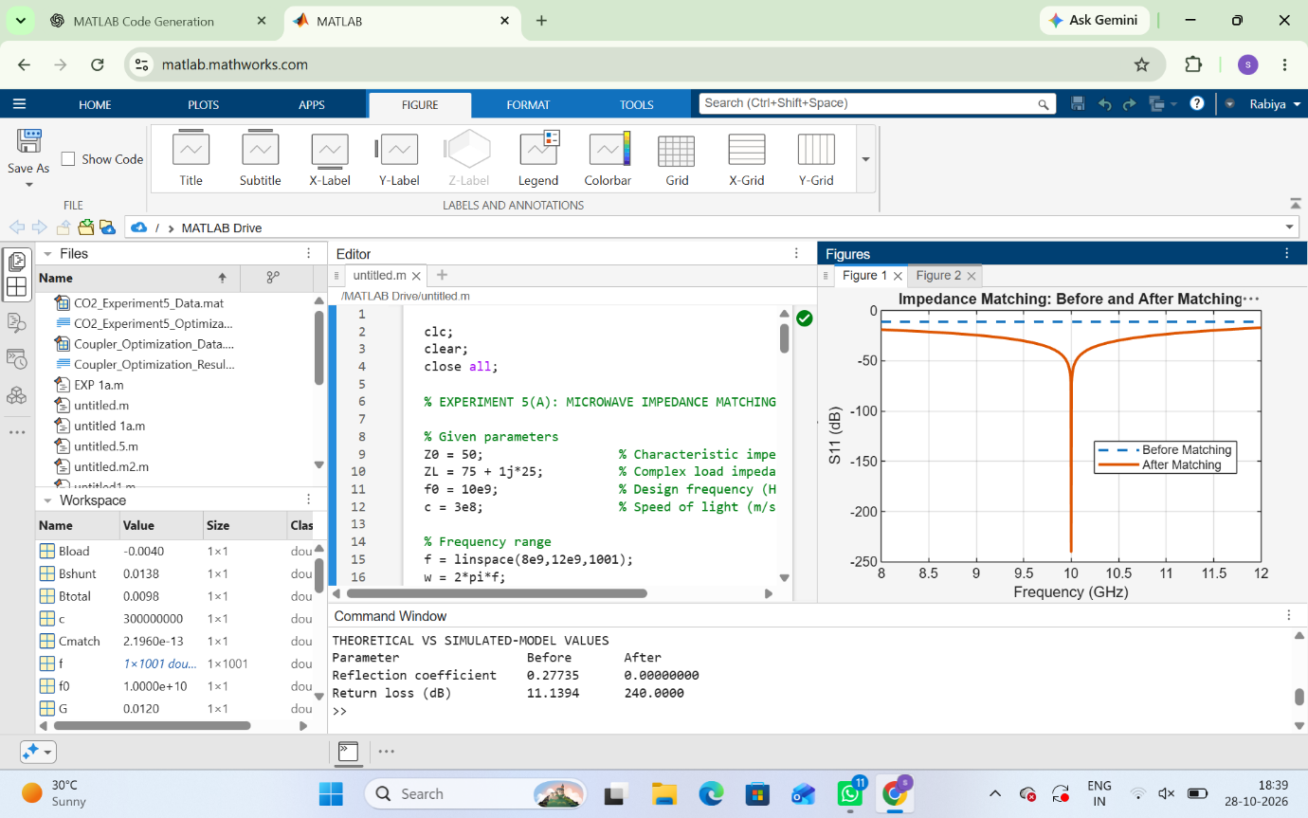

B. Filter Design: Design a 50 Ω frequency-selective filter with cutoff frequency 10 GHz and evaluate it from 8–12 GHz. Obtain S11 and S21, determine the −3 dB cutoff frequency, passband, stopband and insertion loss. Compare the measured/simulated cutoff frequency with 10 GHz and calculate percentage deviation.
CODE:
clc;
clear;
close all;

% EXPERIMENT 5(A): MICROWAVE IMPEDANCE MATCHING

% Given parameters
Z0 = 50; % Characteristic impedance (ohms)
ZL = 75 + 1j*25; % Complex load impedance (ohms)
f0 = 10e9; % Design frequency (Hz)
c = 3e8; % Speed of light (m/s)

% Frequency range
f = linspace(8e9,12e9,1001);
w = 2*pi*f;
w0 = 2*pi*f0;

%% 1. Theoretical values before matching

GammaL = (ZL-Z0)/(ZL+Z0);
Gamma_mag = abs(GammaL);
RL_before = -20*log10(Gamma_mag);

fprintf('PART A: IMPEDANCE MATCHING\n');
fprintf('------------------------------------\n');
fprintf('Load impedance = %.2f + j%.2f ohms\n', ...
real(ZL),imag(ZL));
fprintf('Characteristic impedance = %.2f ohms\n',Z0);
fprintf('Reflection coefficient magnitude = %.6f\n',Gamma_mag);
fprintf('Return loss before matching = %.4f dB\n',RL_before);

%% 2. Design an equivalent L-section matching network
% Topology: shunt capacitor across load and series inductor.
% The load is assumed constant over the frequency range.

YL = 1/ZL;
G = real(YL);
Bload = imag(YL);

% Required total susceptance for a 50-ohm real impedance
Btotal = sqrt(G/Z0-G^2);

% Shunt capacitor susceptance
Bshunt = Btotal-Bload;

% Series inductive reactance needed to cancel residual reactance
Zparallel = 1/(YL+1j*Bshunt);
Xseries = -imag(Zparallel);

% Component values at 10 GHz
Cmatch = Bshunt/w0;
Lmatch = Xseries/w0;

fprintf('\nMATCHING COMPONENTS\n');
fprintf('Shunt capacitance = %.4f fF\n',Cmatch*1e15);
fprintf('Series inductance = %.4f pH\n',Lmatch*1e12);

%% 3. Frequency response before and after matching

% Before matching
Gamma_before = (ZL-Z0)/(ZL+Z0);
S11_before_dB = 20*log10(abs(Gamma_before))*ones(size(f));

% After matching: shunt capacitor and series inductor
Zload_parallel = 1./(1/ZL + 1j*w*Cmatch);
Zin_matched = Zload_parallel + 1j*w*Lmatch;

Gamma_after = (Zin_matched-Z0)./(Zin_matched+Z0);
S11_after_dB = 20*log10(max(abs(Gamma_after),1e-12));
RL_after = -20*log10(max(abs(Gamma_after),1e-12));

% Values at 10 GHz
[~,idx] = min(abs(f-f0));

fprintf('\nRESULTS AT 10 GHz\n');
fprintf('------------------------------------\n');
fprintf('Input impedance after matching = %.4f + j%.4f ohms\n', ...
real(Zin_matched(idx)),imag(Zin_matched(idx)));
fprintf('S11 before matching = %.4f dB\n',S11_before_dB(idx));
fprintf('S11 after matching = %.4f dB\n',S11_after_dB(idx));
fprintf('Return loss after matching = %.4f dB\n',RL_after(idx));
fprintf('Reflection coefficient after matching = %.8f\n', ...
abs(Gamma_after(idx)));

%% 4. Plot S11 response

figure;
plot(f/1e9,S11_before_dB,'--','LineWidth',1.8);
hold on;
plot(f/1e9,S11_after_dB,'LineWidth',2);
grid on;
xlabel('Frequency (GHz)');
ylabel('S11 (dB)');
title('Impedance Matching: Before and After Matching');
legend('Before Matching','After Matching','Location','best');
xlim([8 12]);

%% 5. Plot return loss

figure;
plot(f/1e9,RL_after,'LineWidth',2);
grid on;
xlabel('Frequency (GHz)');
ylabel('Return Loss (dB)');
title('Return Loss of the Matching Network');
xlim([8 12]);

%% 6. Disp
clc;
clear;
close all;

% EXPERIMENT 5(B): MICROWAVE FILTER DESIGN

% Given parameters
Z0 = 50; % Characteristic impedance (ohms)
fc = 10e9; % Specified cutoff frequency (Hz)
N = 5; % Butterworth filter order

% Frequency range: 8 to 12 GHz
f = linspace(8e9,12e9,4001);
x = f/fc;

%% 1. Ideal Butterworth filter response

% Power transmission response
T = 1./(1+x.^(2*N));

% S21 magnitude
S21_mag = sqrt(T);

% Ideal lossless reflection coefficient magnitude
S11_mag = sqrt(1-T);

% Convert to dB
S21_dB = 20*log10(max(S21_mag,1e-12));
S11_dB = 20*log10(max(S11_mag,1e-12));

% Insertion loss
InsertionLoss = -S21_dB;

%% 2. Determine the -3 dB cutoff frequency

% The -3 dB level is defined using the power ratio
target_dB = -10*log10(2);

% Locate the nearest cutoff point
[~,idx] = min(abs(S21_dB-target_dB));
fc_sim = f(idx);

% Percentage deviation
deviation = abs(fc_sim-fc)/fc*100;

fprintf('PART B: BUTTERWORTH LOW-PASS FILTER\n');
fprintf('------------------------------------\n');
fprintf('Characteristic impedance = %.2f ohms\n',Z0);
fprintf('Filter order = %d\n',N);
fprintf('Specified cutoff frequency = %.4f GHz\n',fc/1e9);
fprintf('Simulated-model cutoff frequency = %.4f GHz\n', ...
fc_sim/1e9);
fprintf('Percentage deviation = %.4f %%\n',deviation);

%% 3. Passband and stopband analysis

% Define passband and stopband using the -3 dB cutoff
passband = f < fc_sim;
stopband = f > fc_sim;

fprintf('\nPASSBAND AND STOPBAND\n');
fprintf('Passband range in the evaluated interval: %.2f to %.4f GHz\n', ...
f(1)/1e9,fc_sim/1e9);
fprintf('Stopband range in the evaluated interval: %.4f to %.2f GHz\n', ...
fc_sim/1e9,f(end)/1e9);

% Values at the specified cutoff frequency
[~,idx0] = min(abs(f-fc));

fprintf('\nRESPONSE AT 10 GHz\n');
fprintf('S11 = %.4f dB\n',S11_dB(idx0));
fprintf('S21 = %.4f dB\n',S21_dB(idx0));
fprintf('Insertion loss = %.4f dB\n',InsertionLoss(idx0));

%% 4. Plot S11 and S21

figure;
plot(f/1e9,S11_dB,'LineWidth',2);
hold on;
plot(f/1e9,S21_dB,'LineWidth',2);
yline(-3.0103,'--');
xline(fc/1e9,':');
grid on;
xlabel('Frequency (GHz)');
ylabel('Magnitude (dB)');
title('Butterworth Low-Pass Filter S-Parameters');
legend('S11','S21','-3.01 dB Level','Specified Cutoff', ...
'Location','best');
xlim([8 12]);
ylim([-80 0]);

%% 5. Plot insertion loss

figure;
plot(f/1e9,InsertionLoss,'LineWidth',2);
hold on;
yline(3.0103,'--');
grid on;
xlabel('Frequency (GHz)');
ylabel('Insertion Loss (dB)');
title('Insertion Loss versus Frequency');
legend('Insertion Loss','3.01 dB Cutoff Level', ...
'Location','best');
xlim([8 12]);

%% 6. Output comparison table

fprintf('\nOUTPUT COMPARISON\n');
fprintf('------------------------------------\n');
fprintf('Specified cutoff frequency = %.4f GHz\n',fc/1e9);
fprintf('Calculated cutoff frequency = %.4f GHz\n',fc_sim/1e9);
fprintf('Percentage deviation = %.4f %%\n',deviation);
fprintf('Insertion loss at cutoff = %.4f dB\n',InsertionLoss(idx0));
lay output comparison

fprintf('\nTHEORETICAL VS SIMULATED-MODEL VALUES\n');
fprintf('Parameter Before After\n');
fprintf('Reflection coefficient %.5f %.8f\n', ...
abs(GammaL),abs(Gamma_after(idx)));
fprintf('Return loss (dB) %.4f %.4f\n', ...
RL_before,RL_after(idx));

